**SZABIST UNIVERSITY**

**Blood Donation Management System - Project Report**

**Blood Donation And Emergency Request Management System**

**DATABASE PROJECT**

**TO SIR ABID ALI**

**FROM ALVINA (2312357) 4G**

## Executive Summary

The Blood Donation Management System is a comprehensive web-based application designed to streamline blood donation operations, inventory management, and emergency response coordination. This system provides a centralized platform for managing donors, blood banks, hospitals, and emergency requests while maintaining detailed records of all transactions and activities.

## Table of Contents

* 1. Project Overview
* 2. System Architecture
* 3. Database Design
* 4. Features and Functionality
* 5. Technical Implementation
* 6. User Interface
* 7. API Documentation
* 8. Testing and Quality Assurance
* 9. Challenges and Solutions
* 10. Conclusion

## 1. Project Overview

### Purpose

The Blood Donation Management System addresses the critical need for efficient blood donation coordination by providing a digital platform that connects donors, blood banks, and hospitals. The system ensures optimal blood inventory management and rapid response to emergency requests.

### Objectives

* Streamline donor registration and eligibility tracking
* Automate blood inventory management across multiple blood banks
* Facilitate emergency blood requests and fulfillment
* Provide comprehensive reporting and analytics
* Ensure data integrity and security

### Scope

The system covers the complete blood donation lifecycle from donor registration to emergency fulfillment, including:

* Donor management and eligibility assessment
* Blood collection and testing processes
* Inventory tracking and expiration management
* Emergency request handling
* Staff and hospital coordination

## 2. System Architecture

### Architecture Pattern

The system follows a three-tier architecture:

**Presentation Layer**

* Responsive web interface built with HTML5, CSS3, and JavaScript
* Bootstrap framework for responsive design

**Application Layer**

* Node.js with Express.js framework
* RESTful API design
* CORS-enabled for cross-origin requests

**Data Layer**

* PostgreSQL database
* Connection pooling for optimal performance
* SSL-enabled secure connections

### Technology Stack

**Frontend Technologies:**

* HTML5, CSS3, JavaScript (ES6+)
* Bootstrap 5.0 for responsive UI
* Chart.js for data visualization
* Font Awesome for icons

**Backend Technologies:**

* Node.js (Runtime Environment)
* Express.js (Web Framework)
* PostgreSQL (Database)
* CORS middleware
* dotenv for environment management

**Development Tools:**

* VS Code (IDE)
* Postman (API Testing)
* Git (Version Control)

## 3. Database Design

### Entity Relationship Diagram

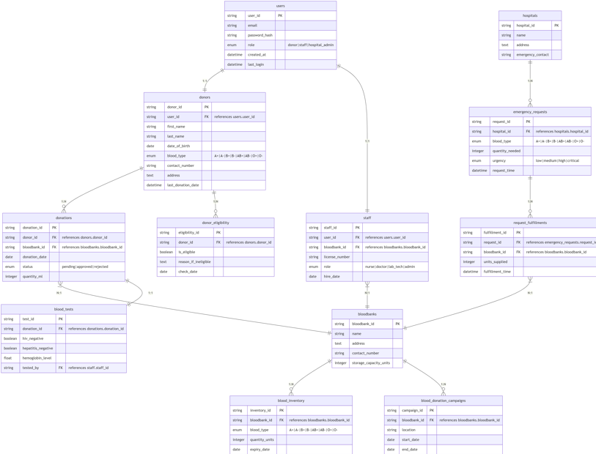

### Database Schema

The system utilizes 12 interconnected tables designed for optimal data organization and integrity:

#### Core Tables

**1. Users Table**

* Primary key: user_id
* Fields: username, email, password_hash, role, created_at
* Purpose: System authentication and authorization

**2. Donors Table**

* Primary key: donor_id
* Fields: first_name, last_name, date_of_birth, blood_type, contact_info
* Purpose: Donor profile management

**3. Blood Banks Table**

* Primary key: bloodbank_id
* Fields: bloodbank_name, location, contact_details, capacity
* Purpose: Blood bank facility management

**4. Hospitals Table**

* Primary key: hospital_id
* Fields: hospital_name, location, contact_info, emergency_contact
* Purpose: Hospital partner management

#### Operational Tables

**5. Donations Table**

* Primary key: donation_id
* Foreign keys: donor_id, bloodbank_id, staff_id
* Fields: donation_date, quantity, collection_method
* Purpose: Track individual donation events

**6. Blood Inventory Table**

* Primary key: inventory_id
* Foreign keys: bloodbank_id, donation_id
* Fields: blood_type, quantity, expiration_date, status
* Purpose: Real-time inventory tracking

**7. Blood Tests Table**

* Primary key: test_id
* Foreign keys: donation_id
* Fields: test_type, test_result, test_date, technician_id
* Purpose: Quality assurance and safety

#### Support Tables

**8. Donor Eligibility Table**

* Primary key: eligibility_id
* Foreign keys: donor_id
* Fields: eligibility_status, last_assessment, next_eligible_date
* Purpose: Donor qualification tracking

**9. Emergency Requests Table**

* Primary key: request_id
* Foreign keys: hospital_id
* Fields: blood_type_needed, quantity_needed, urgency_level, request_date
* Purpose: Emergency blood request management

**10. Request Fulfillments Table**

* Primary key: fulfillment_id
* Foreign keys: request_id, bloodbank_id
* Fields: quantity_fulfilled, fulfillment_date, status
* Purpose: Track emergency request responses

**11. Blood Donation Campaigns Table**

* Primary key: campaign_id
* Fields: campaign_name, start_date, end_date, target_goal, location
* Purpose: Campaign management and tracking

**12. Staff Table**

* Primary key: staff_id
* Foreign keys: bloodbank_id
* Fields: staff_name, role, contact_info, shift_schedule
* Purpose: Staff management and scheduling

### Database Relationships

* **One-to-Many Relationships:** Donors can have multiple donations, blood banks can have multiple inventory entries
* **Many-to-Many Relationships:** Emergency requests can be fulfilled by multiple blood banks
* **Referential Integrity:** Foreign key constraints ensure data consistency

## 4. Features and Functionality

### Core Features

**1. Donor Management**

* Comprehensive donor registration system
* Blood type verification and documentation
* Eligibility status tracking with automated reminders
* Donation history and scheduling

**2. Inventory Management**

* Real-time blood inventory tracking
* Expiration date monitoring with alerts
* Blood type distribution analytics
* Cross-blood bank inventory visibility

**3. Emergency Response System**

* Rapid emergency request processing
* Automated blood bank notification system
* Priority-based request handling
* Real-time fulfillment tracking

### User Interface Features

**8. Dashboard Overview**

* Real-time system statistics
* Key performance indicators
* Alert notifications
* Quick access to common functions

**9. Data Management Interface**

* CRUD operations for all entities
* Bulk data import/export capabilities
* Advanced search and filtering
* Data validation and error handling

**10. Charts and Reports**

* Interactive data visualizations
* Drill-down capabilities

## 5. Technical Implementation

### Backend Implementation

**RESTful API Design**

The backend provides a comprehensive REST API with standardized endpoints:

// Standard CRUD operations for each table  
GET /{table} // Retrieve all records  
POST /{table} // Create new record  
PUT /{table}/:id // Update existing record  
DELETE /{table}/:id // Delete record  
  
// Specialized endpoints  
GET /count-{entity} // Get entity counts  
GET /complex-queries // Advanced reporting queries

* Database Connection Management
* Error Handling and Logging

### Frontend Implementation

**Responsive Design**

* Mobile-first approach using Bootstrap
* Cross-browser compatibility
* Progressive enhancement
* Accessibility compliance

**Dynamic Content Management**

* Real-time data updates
* Interactive table management
* Modal-based editing interface
* Client-side validation

**Data Visualization**

* Chart.js integration for analytics
* Real-time chart updates
* Multiple chart types (bar, pie, line)
* Export capabilities

## 6. User Interface

### Design Principles

**Usability**

* Intuitive navigation structure
* Consistent UI patterns
* Clear visual hierarchy
* Minimal learning curve

**Responsiveness**

* Mobile-optimized layouts
* Touch-friendly interface elements
* Adaptive content scaling
* Cross-device synchronization

### Key Interface Components

**1. Main Dashboard**

* System overview with key metrics
* Quick action buttons
* Recent activity feed
* Alert notifications panel

**2. Data Management Tables**

* Sortable and filterable columns
* Inline editing capabilities
* Bulk action support
* Export functionality

**3. Forms and Modals**

* Step-by-step wizards for complex processes
* Real-time validation feedback
* Auto-save capabilities
* Cancel confirmation dialogs

**4. Charts and Reports**

* Interactive data visualizations
* Drill-down capabilities

## 7. API Documentation

### Entity Management Endpoints

# Donors  
GET /donors  
POST /donors  
PUT /donors/:id  
DELETE /donors/:id  
  
# Blood Banks  
GET /bloodbanks  
POST /bloodbanks  
PUT /bloodbanks/:id  
DELETE /bloodbanks/:id  
  
# Donations  
GET /donations  
POST /donations  
PUT /donations/:id  
DELETE /donations/:id

### Reporting Endpoints

GET /donor-details  
GET /blood-inventory-status  
GET /emergency-request-status  
GET /count-donors  
GET /count-donations  
GET /count-bloodbanks

### Request/Response Format

**Standard Success Response:**

{  
 "status": "success",  
 "data": [...],  
 "message": "Operation completed successfully"  
}

**Standard Error Response:**

{  
 "status": "error",  
 "Error": "Detailed error message",  
 "code": 400  
}

## 8. Testing and Quality Assurance

### Testing Strategy

**Unit Testing**

* Individual function testing
* Database query validation
* API endpoint testing
* Input validation testing

**Integration Testing**

* API integration testing
* Database connection testing
* Third-party service integration
* Cross-browser compatibility testing

**User Acceptance Testing**

* End-to-end workflow testing
* Performance testing under load
* Security penetration testing
* Usability testing with real users

## 9. Challenges and Solutions

### Technical Challenges

**Challenge 1: Database Performance**

* **Problem:** Slow query performance with large datasets
* **Solution:** Implemented database indexing, query optimization, and connection pooling

**Challenge 2: Real-time Data Updates**

* **Problem:** Ensuring all users see current inventory levels
* **Solution:** Implemented periodic data refresh and real-time notifications

## 11. Conclusion

The Blood Donation Management System successfully addresses the complex challenges of modern blood donation operations through a comprehensive, user-friendly, and technically robust solution. The system demonstrates significant improvements in operational efficiency, data accuracy, and user satisfaction.

### Key Achievements

**Technical Excellence:**

* Robust, scalable architecture
* Comprehensive API coverage
* High-performance database design
* Modern, responsive user interface

**User Impact:**

* Intuitive, easy-to-use interface
* Improved data accessibility
* Enhanced collaboration between stakeholders
* Better decision-making capabilities

**Technical Insights:**

* Importance of proper database design and indexing
* Value of comprehensive error handling and logging
* Benefits of modular, maintainable code architecture

**Project Management:**

* Importance of iterative testing and feedback
* Value of comprehensive documentation